# **2 - second class notes (2365) - Unit two health and safety**

In this class we went over health and safety in further details.

When it comes to the wires:

* **Blue** is neutral,
* **Brown** is line; it is also referred to as live interchangeably,
* **yellow** and **green** is for earth (cpc).

A little tip to remember the colour sequence is the following.

* **Blue** is the colour of the ocean and the sky. Blue is calm and otherwise known as neutral.
* Chris **brown** is performing live. Therefore **brown** is live.
* The grass is **green** and **yellow**. Green grass and yellow crops. Therefore the earth wire is green and yellow.

**Safe isolation process recap:**

1 – Seek permission – let the end user know you will switch the power off

2 – Find the suitable point of isolation; lock the fuse board for example

3 – AVI – Approved Voltage Indicator to conduct an electricial test. GS38 applied to any test electrical equipment

4 – Prove the circuit is working

5 – single phase – three tests. Three phase circuit requires 10 tests.

6 – Retest to ensure that the test equipment is not faulty.

7 – turn off and put padlock and notice

8 – always put cover on exposed electrical units when not in the vicinity.

**Risk Assessments (RA)**The main cause of a risk assessment is to eliminate the hazard.

For example, use battery powered tools instead of tools rather than tools that require a cable.

* Safe systems of work (SSOW) – method statement combined with permit that says you are able to complete the job.
* Training – Manual handling so that your company cannot be sued.
* Provide PPE if the hazard cannot be removed or minimised.
* Collective approach vs individual approach. Seek to implement the former. For example, implement a scaffold rather than individuals having an individual harness.
* Hazard is something with the potential to cause harm. For example, working with electricity.
* Risk – is the likelihood of harm
* Risk Matrix

When your company does not follow a risk assessment. The employer benefits because they save money at the expense of the employee’s well-being.

Tutor said that you can refuse to complete a task if you deem it to be dangerous. If you are sacked as a consequence; then you can take your employer to court.

**Risk assessment process**

step 1 – identify the hazard

step 2 – identify who could be harmed

Step 3 – evaluate risk and decide of the precautions

step 4 – record findings and implement

step 5 – review risk assessments and update.

HSE provide a online risk assessment template.

Legal requirement to have written risk assessment when you have five or more employees.

Health and safety – covers work from home and volunteering.

Employers must consult employees on H and S issues. Consultations must be direct with workforce or via elected H &S rep.

Main contractor -> sub-contractor -> worker (you/ self-employed)

The main contractor’s risk assessment overrides the sub-contractor’s risk assessment.

**Reporting to H&S executive**

HSE provide non-statutory guidance which helps you comply to the Health and Safety Work Act 1974.

Employer cannot dismiss employee for a complaint lodge about H&S. As this is classified as unfair dismissal.

**Access equipment**

Pole ladders – old style of ladder

Extension ladders – new style foldable, multi-selection

Step ladders – made of fibre glass as it does not conduct electricity.

Roof ladders – used on sloped roof. Accessed from scaffold.

Ladder should have stabiliser on the feet to prevent swaying. Ladders should stand at an angle of 75 degrees at a ration of 1 to 4. 1 for every 4 up. Ladder over 3m long must be secured or otherwise footed by cohort.

Extend ladder pass point of access; so that you may side step off.

**Pre-use checks for a ladder**

* missing or damaged feet,
* check the stiles and rungs,
* wear and tear or missing screw.

**Tower scaffold**

* PASMA (prefabricated Access to Supplier’s and Manufacturers’ Assosciation)
* A one day training course to build tower scaffolders
* tower scaffolds can be built up to ten metres high
* tower requirements – sole platers must be used to provide even weigh distribution
* Do not mount a tower scaffolder when it is moved around. Also tower scaffolder needs to be a certain height when moved around (not too high as increases chance that it can fall over)

podium ladders]Mobile scissor lifts, cherry picker and crawling boards.

**Safety signs**

Warning signs – yellow background with black picture

information signs – green background with white picture

mandatory – blue

prohibition – red circle and diagonal red line through the circle. Behaviours that are no tolerated.

Fire fighting signage is in red

hazardous substances are red and white in colour

All hazardous substance symbols are in a diamond shaped sign.

pre-2004 the wire colours were. **Red – live** and **Black – neutral**. Post – 2004 the wires were harmonised between the UK and Europe. Hence the colours **blue (neutral)**, **brown (line/live)** and green & yellow (earth/cpc)

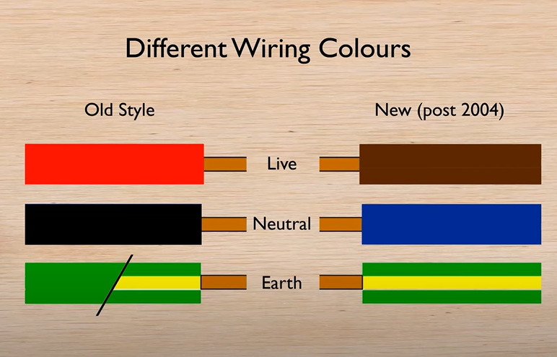

**Accident and emergency procedures**

In the event of an electrical accident switch off the power. You cannot be sued in your attempt to resuscitate a person to life.

**Ring circuit**

In the second class we built a ring circuit. We changed the **radial circuit** that was created in the first class into a **ring circuit**.

**Radial Circuit** – Does not come back to the fuse board. Electricity flows from the fuse box to multiple points. Can only have a certain number, limited amount of sockets.

**Ring circuit** – Returns back to the fuse board. Therefore, the circuit can take more load. Therefore, on the fuse box we could use the 32 amp breaker instead of the 16 amp breaker. Can have an unlimited amount of sockets.

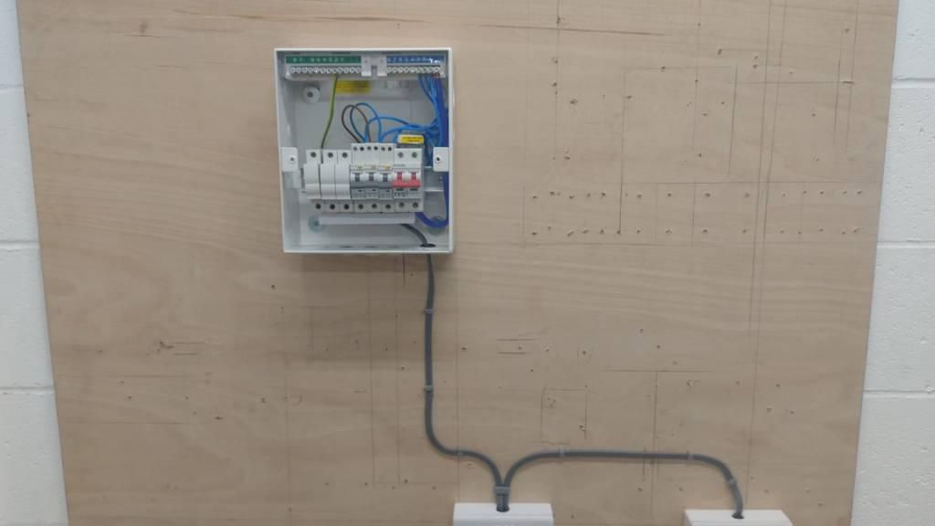**Radial circuit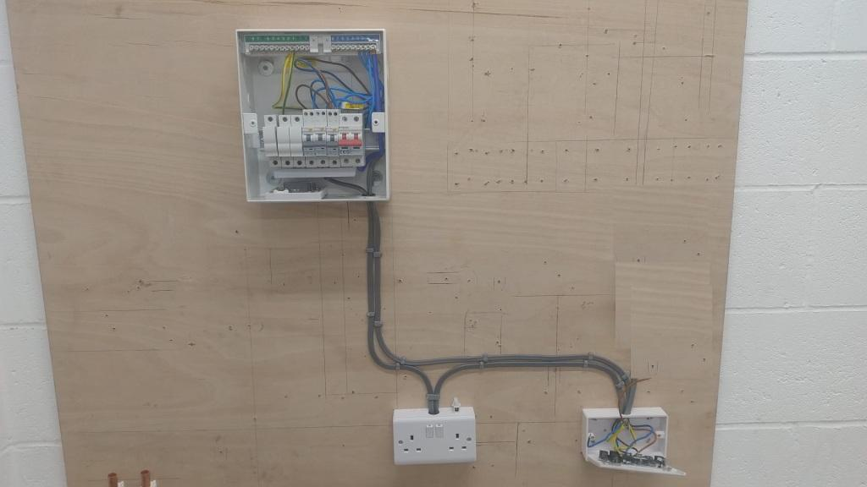Ring circuit**